Swashbuckler 1700
- Dread Pyrate
- Member

- 1,115 posts
- Gender:Male
- Location:Europe
- Interests:pyrates, pryvateers, naval military and other history, different books, good movies, music (a little bit), drawing, games,...
(IP: 80.223.160.249) ·
Posted April 14, 2012 · Report post
I was wondering how people were hang in 1600s and in 1700s.
I am not going to hang anyone but I was wondering....
I have found mainly period pics with carriages but what about other ways...
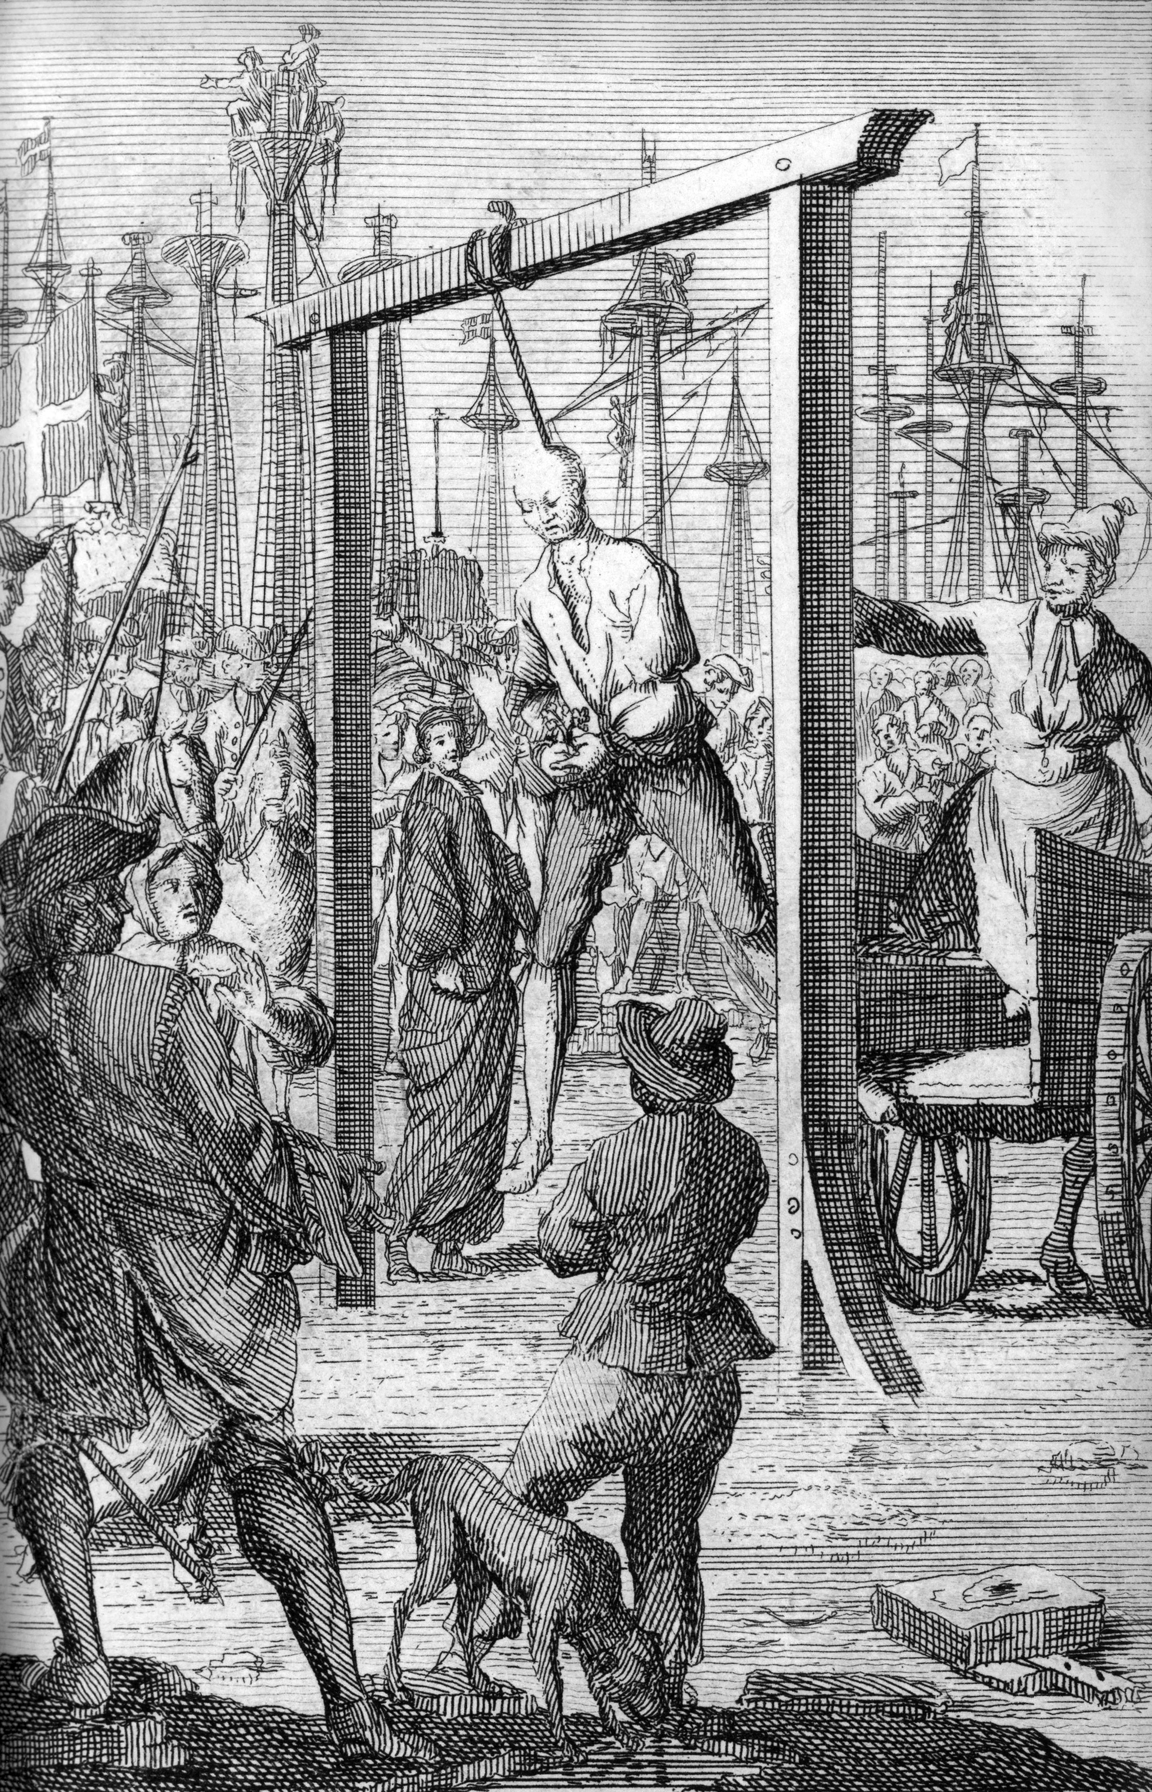

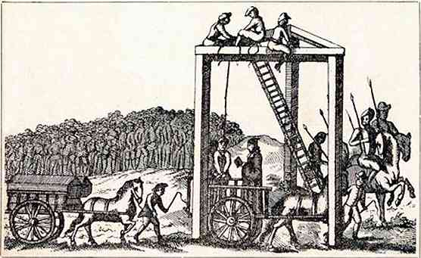

- Quote
- Edit

RIPP Tar
- First Mate
- Member

- 266 posts
- Gender:Male
- Location:Rhode Island
- Interests:Piracy in Rhode Island
(IP: 68.9.211.62) · ·
Posted April 14, 2012 · Report post
I have read some that say on ships often the rope was sent over the yard, on end had a noose which was placed around the neck, the other end was given to a number of sailor who would the haul up the condemned. this basically would slowly strangle the victim.

- Quote
- Edit
- Options

Grymm
- First Mate
- Member

- 281 posts
- Gender:Male
- Location:Chilterns UK
- Interests:Stuff
(IP: 109.150.211.249) · ·
Posted April 18, 2012 · Report post
The cart journey was a common thing for big cities certainly, some took a winding route stopping at pubs for gin or porter for the 'star' of the show.
To stop the agony of a long strangulation some would leap from the cart or ladder in an effort to snap their neck and on other occasions a number of friends would grab onto and swing from the ....victim (is the wrong word but it'll have to do) to speed up death.
Account of Turpin's journey in Yorl '39 (Nasty wee bugger he was)
he was taken from the York castle's condemned cell and driven in a horse drawn cart through the imposing gateway of the castle and along Castlegate. Crowds would line the route as they made their way over Ouse Bridge, the only road bridge across the river at that time. Along Ousegate and continuing up the steep slope of Micklegate, they would have driven through Micklegate bar and onto Blossom Street, The Mount, and finally to the Knavesmire, the site of the gallows.......... He carried himself with much dignity to the last and, after speaking a few words, he turned and threw himself from the ladder and died after a few minutes.
In '24 Sheppard's procession halted at the City of Oxford tavern on Oxford Street, where Sheppard drank a pint of sack.
More Hogarth, an etching from Industry and Idleness
The Idle 'Prentice Executed at Tyburn

- Quote
- Edit
- Options

Swashbuckler 1700
- Dread Pyrate
- Member

- 1,115 posts
- Gender:Male
- Location:Europe
- Interests:pyrates, pryvateers, naval military and other history, different books, good movies, music (a little bit), drawing, games,...
(IP: 80.223.160.249) · ·
Posted April 18, 2012 (edited) · Report post
On 4/18/2012 at 0:14 PM, Grymm said:
The cart journey was a common thing for big cities certainly, some took a winding route stopping at pubs for gin or porter for the 'star' of the show.
To stop the agony of a long strangulation some would leap from the cart or ladder in an effort to snap their neck and on other occasions a number of friends would grab onto and swing from the ....victim (is the wrong word but it'll have to do) to speed up death.
Account of Turpin's journey in Yorl '39 (Nasty wee bugger he was)
he was taken from the York castle's condemned cell and driven in a horse drawn cart through the imposing gateway of the castle and along Castlegate. Crowds would line the route as they made their way over Ouse Bridge, the only road bridge across the river at that time. Along Ousegate and continuing up the steep slope of Micklegate, they would have driven through Micklegate bar and onto Blossom Street, The Mount, and finally to the Knavesmire, the site of the gallows.......... He carried himself with much dignity to the last and, after speaking a few words, he turned and threw himself from the ladder and died after a few minutes.
In '24 Sheppard's procession halted at the City of Oxford tavern on Oxford Street, where Sheppard drank a pint of sack.
More Hogarth, an etching from Industry and Idleness
The Idle 'Prentice Executed at Tyburn

Man With the crutches and scarf LOOKS LIKE stereotypical PIRATE ( joke.... laugh! ) please add that to " Aye the kerchief" tread it would be nice addition there.
Lovely skeletons there
oh there is another man with bandana....
Odd that there is a coffin? I would have think that criminals would not have kind of "luxury".....
Edited April 18, 2012 by Swashbuckler 1700

- Quote
- Edit
- Options

oderlesseye
- Scourge o' the 7 Seas
- Member

- 2,126 posts
- Gender:Male
- Location:San Diego, Ca. (North Park) me cove !
- Interests:Oderlesseye is a mutinous two bit sand dollar with a thirst for adventure. Sailing on tall ships, firing black powder weapons, and sword fighting.. I most love to entertain the public in piratical skit presentations that involve all of the above. My name is befitting of my position on board as that of the look-out. Some ask what’s the meaning of the name Oderlesseye...It is simple really.. When Eye am aloft, ye can’t smell me...But it’s spelled wrong some exclaim! Hey now! What pirate can spell? - is my retort!
I have been an active member of the pirate community since 2005. I consider myself a fan of living history in the Golden Age of Piracy. As a child I , like the lot of ye, loved the old time pirate movies with Errol Flynn and Douglas Fairbanks. Long live Long John Silver !
Inspired by them, Eye created a Pirate Ninja Movie called "Treachery and a Dead Mans Promise" Available on YouTube.
Being a pirate, as it turns out, is multi-dimensional. For me, a lifestyle has been carved out of it. There is a six foot tall skeleton pirate in a make shift hide out called Dead Mans Cove behind my house. The walls are painted giving the impression you are in a sea cave. There is a mural of a pirate coming ashore in a long boat at the mouth of the cove. Believe me, it is a great place to enjoy rum now and again!
Exploration into all things piratical have led me to being an attempted escapee from the Governors noose to impersonating a judge in the Anne Bonnie and Mary Read trial held in Pirates In Paradise.. As Oderlesseye, my one on one impression to patrons is as one whom barley escaped the flames of the ship we took when the powder magazine blew with the booty in me hands from the Captains quarters.. The tale explains the soot on me face, the tattered clothing, and the burnt tricorn, as I hand out a gold coin or two. I hate them plastic ones and I know kids appreciate the metal coins even more so.
When an event is slated for a historical time line presentation to the public, I do not do these things mentioned above. Rather, I share about what is a grape shot or how a flintlock works. I ware clothing that is more closely representing the era in these cases. I am still updating me togs (Period Kit) as I learn more thru fellow pirates and sources like the Pyracy Pub.
So far, there have been many exciting moments of adventure the world of PIRACY has afforded me. From standing on a bar top with Pirates Charles singing to me in New Orleans to shooting cannons ( Ships Guns for you PC Pirates!), on the tall ship Spirit of Dana Point. Cheers from a crowd during a show as last man standing on the Treasure chest proclaiming to an excited crowd ITS MINE! THE BOOTY IS MINE ! YARR ! ~ These things and the notoriety that comes with being a pirate has me hooked! Whats More Is the greater bonds of friendships that have been forged with those whose course finds me at such events, sharing the same love and passion of the Life within the pirate/reenactment community. To Them Eye take me hat off and offer a tot of Rum! Cheers mates!
(IP: 72.220.190.137) · ·
Posted April 18, 2012 (edited) · Report post
hangin is hangin !
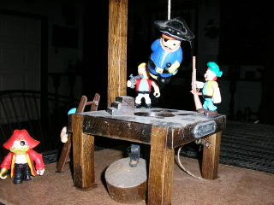
Edited April 18, 2012 by oderlesseye

- Quote
- Edit
- Options

Mission
- Goat Specialist
- Admin

- 5,082 posts
- Gender:Male
- Location:Monroe, MI
- Interests:Scholarly piracy, designing and creating haunted house rooms and props, movies, abstract thinking, abstruse thinking, obstructive thinking, ideating, random thinking, movies, cartoons, movies, movies scores, cycling, world peace and small furry dogs, movies, writing, drawing, personal skills training, gremlins and, of course, lest I forget, movies.
(IP: 24.247.94.112) · ·
Posted April 19, 2012 · Report post
On 4/18/2012 at 0:14 PM, Grymm said:
More Hogarth, an etching from Industry and Idleness
The Idle 'Prentice Executed at Tyburn

So why is the guy in the lower right hand corner selling fruit? Is it for eating or throwing? (Just curious.)

- Quote
- Edit
- Options

Jib
- Dread Pyrate
- Member

- 1,078 posts
- Gender:Male
- Location:Minneapolis, MN
- Interests:Piracy, stage combat, martial arts, reading, film, travel
(IP: 198.12.16.4) · ·
Posted April 19, 2012 · Report post
Images of the famous "Tyburn Tree". Very nice!

- Quote
- Edit
- Options

Capt. Sterling
- Sticky Fingers Sterling Needs a New Hat
- Member

- 10,302 posts
- Gender:Pyrate Hunter
- Location:here
- Interests:Killing pirates, haven't met one yet worth keeping alive....
(IP: 67.237.180.88) · ·
Posted April 19, 2012 · Report post
On 4/19/2012 at 8:40 AM, Mission said:
On 4/18/2012 at 0:14 PM, Grymm said:
More Hogarth, an etching from Industry and Idleness
The Idle 'Prentice Executed at Tyburn

So why is the guy in the lower right hand corner selling fruit? Is it for eating or throwing? (Just curious.)
Actually could be both, but odds are for eating, unless oranges at the time were a relatively inexpensive item. If ye really wanted to throw something, ye could most likely find something dirt cheap on the ground. Hangings were big affairs, quite the "holiday" atmosphere, so one could imagine folks taking the opportunity to sell to the crowds.

- Quote
- Edit
- Options

Tar Bucket Bill
- Deck Hand
- Member

- 80 posts
- Gender:Male
- Location:Indianapolis, Ind.
- Interests:Pillagin', plunderin', riflin', lootin', kidnappin', ravagin' and splicin' the mainbrace whenever I can. Hehe.
(IP: 99.6.4.192) · ·
Posted April 19, 2012 (edited) · Report post
WARNING: If you are easily offended by graphic descriptions of death and dying or squeamish, please do not read this!
If I recall correctly, Captain Kidd was carted to the gallows which was placed between the tides on the Thames, because between the tides was within the perview of the Admiralty Court for crimes on the ocean. They often stopped and let him drink alcohol on the way from the prison to the gallows, so he became quite drunk. It was a journey across part of London. When they reached the gallows at Execution Dock in Wapping on the Thames he was then placed upon a collapsible platform with others to be hanged and the rope placed around his neck, his hands tied probably to the front, but the feet not tied.Sometimes a white hood was placed over the head. The executioner then collapsed the platform, thus letting the condemned dangle and do the "hempen jig". The feet and legs, being not tied, would often kick about in this "hempen jig" to the delight of the public. Kidd's rope broke and he fell to the ground. They raised a ladder to the gallows and forced him to climb the ladder and then "turned him off" the ladder to let him dangle and expire to complete the execution. It could often take 15 or 2o minutes for someone to strangle to death this way. Tongues bitten and blood streaming from mouths. Cheers would be raised when a wet spot formed at the crotch of the executed upon death. They would be left to hang about half an hour. Sometimes taken down and tied to a post to let three tides wash over the body. About a day and half? And then, if they were pirates, they would often be consigned an unknown, unconsecrated grave. Or in Captain Kidd's case, they slathered him with pitch or tar, encased him in a gibbet cage and hanged him from a gibbet at a place near Tilbury Fort several miles upstream for maybe about 3 years. Poor buggers executed for treason often had it much worse though. Execution for treason often entailed drawing, hanging and quartering.
There. I TOLD you not to read it.
Tar Bucket Bill
Edited April 20, 2012 by Tar Bucket Bill

- Quote
- Edit
- Options

Jib
- Dread Pyrate
- Member

- 1,078 posts
- Gender:Male
- Location:Minneapolis, MN
- Interests:Piracy, stage combat, martial arts, reading, film, travel
(IP: 198.12.16.4) · ·
Posted April 20, 2012 · Report post
I seem to remember reading that Guy Fawkes was sentenced to be drawn and quartered after being hung (but not until dead). While he was being turned off the ladder he leapt and broke his neck in the noose, thus denying the public the show they had hoped for.

- Quote
- Edit
- Options

Capn Bob
- Pyrate Captain
- Member

- 559 posts
- Location:Akron OH...which is not where I want to be...
- Interests:Piracy, fishing, piracy, obsidian, gold, piracy, flintknapping (am I the world's first "Caveman Pirate"?), gold, piracy, gold obsidian...and a good slab of bbq ribs.
(IP: 98.27.138.242) · ·
Posted April 21, 2012 (edited) · Report post
I have heard that, in some cases, after the miscreant had...dangled...a bit, his friends were permitted to pull down on his legs to shorten his sufferings. A good period source for hangings is the Newgate Calender. You can find some selected stories here...
http://www.ryerson.c...ff/newgate.html
and you can download the entirei Calender to read at your leisure here... http://www.exclassic...ate/ngintro.htm
Capn Bob tastelessly sings: "He's swinging in the rain...just swinging in the rain..."
Edited April 21, 2012 by Capn Bob

- Quote
- Edit
- Options

Grymm
- First Mate
- Member

- 281 posts
- Gender:Male
- Location:Chilterns UK
- Interests:Stuff
(IP: 86.183.160.158) · ·
Posted April 22, 2012 (edited) · Report post
Downloads of selected sections from it about Pirates and nautical crimes here http://www.exclassic...ate/ngcontf.htm
And this site has a few refs too, http://www.executedtoday.com/ look on the right and in the categories box pull up 17th or 18thC, it also has a bit for pirates http://www.executedtoday.com/category/who/pirates/
Edited April 22, 2012 by Grymm

- Quote
- Edit
- Options

Fox
- Old Twillian
- Moderator

- 2,564 posts
- Gender:Male
- Location:Beautiful lush Devon, England
- Interests:Nautical history of the 16-18th centuries and living history based thereon.
Shooting pirates.
(IP: 86.147.77.188) · ·
Posted May 3, 2012 · Report post
Not strictly on-topic, but this amused me. It was customary for a number of newspaper to print summaries of the births and deaths that occurred, and this one made me chuckle:
"Drowned accidentally in the River of Thames, 3
Executed, 3 [all pirates]
Kill'd, 2
Overlaid, 1
Press'd to death by the Crowd of People, at the Execution of the Pirates, 1"
From Parker's Penny Post, 18 June, 1725.

- Quote
- Edit
- Options

Mission
- Goat Specialist
- Admin

- 5,082 posts
- Gender:Male
- Location:Monroe, MI
- Interests:Scholarly piracy, designing and creating haunted house rooms and props, movies, abstract thinking, abstruse thinking, obstructive thinking, ideating, random thinking, movies, cartoons, movies, movies scores, cycling, world peace and small furry dogs, movies, writing, drawing, personal skills training, gremlins and, of course, lest I forget, movies.
(IP: 24.247.94.112) · ·
Posted May 3, 2012 · Report post
On 5/3/2012 at 7:54 AM, Foxe said:
Not strictly on-topic, but this amused me. It was customary for a number of newspaper to print summaries of the births and deaths that occurred, and this one made me chuckle:
"Drowned accidentally in the River of Thames, 3
Executed, 3 [all pirates]
Kill'd, 2
Overlaid, 1
Press'd to death by the Crowd of People, at the Execution of the Pirates, 1"
From Parker's Penny Post, 18 June, 1725.
So if all these were from the hanging, the pirates actually sort of won based on the death count.
I wonder what 'Overlaid' means?

- Quote
- Edit
- Options

Fox
- Old Twillian
- Moderator

- 2,564 posts
- Gender:Male
- Location:Beautiful lush Devon, England
- Interests:Nautical history of the 16-18th centuries and living history based thereon.
Shooting pirates.
(IP: 86.147.77.188) · ·
Posted May 3, 2012 · Report post
No, only the executions and the person crushed to death are from the hanging, the others are just 'accidental' deaths also recorded in the same paper. I believe 'overlaid' is knocked down by a horse or wagon.

- Quote
- Edit
- Options

Swashbuckler 1700
- Dread Pyrate
- Member

- 1,115 posts
- Gender:Male
- Location:Europe
- Interests:pyrates, pryvateers, naval military and other history, different books, good movies, music (a little bit), drawing, games,...
(IP: 80.223.160.249) · ·
Posted May 3, 2012 · Report post
On 5/3/2012 at 7:54 AM, Foxe said:
Not strictly on-topic, but this amused me. It was customary for a number of newspaper to print summaries of the births and deaths that occurred, and this one made me chuckle:
"Drowned accidentally in the River of Thames, 3
Executed, 3 [all pirates]
Kill'd, 2
Overlaid, 1
Press'd to death by the Crowd of People, at the Execution of the Pirates, 1"
From Parker's Penny Post, 18 June, 1725.
At least Cordingly was right when he said that "The pirate Execution was a public spectacle".
Really interesting and it seems that there were still pirates to be killed in 1725.

- Quote
- Edit
- Options

Capt. Sterling
- Sticky Fingers Sterling Needs a New Hat
- Member

- 10,302 posts
- Gender:Pyrate Hunter
- Location:here
- Interests:Killing pirates, haven't met one yet worth keeping alive....
(IP: 65.160.148.76) · ·
Posted May 3, 2012 · Report post
Honestly it appears that most, hangings, pirate or not, as well as other styles of execution, were quite the event...

- Quote
- Edit
- Options

Fox
- Old Twillian
- Moderator

- 2,564 posts
- Gender:Male
- Location:Beautiful lush Devon, England
- Interests:Nautical history of the 16-18th centuries and living history based thereon.
Shooting pirates.
(IP: 86.147.77.188) · ·
Posted May 3, 2012 · Report post
William Fly and his company were hanged in 1726, and John Upton went to the gallows in 1728 eating a biscuit. And there was a pirate crew hanged in Williamsburg VA in 1729. There were also lots of pirate executions outside the GAoP If memory serves a bunch of people were hanged for piracy in London in the 1730s too.

- Quote
- Edit
- Options

William Brand
- Mercury Malefactor
- Admin

- 8,884 posts
- Gender:Male
- Location:Logan, Utah
- Interests:My name is William Pace and I live and work as a graphic designer, illustrator and photographer in Northern Utah. I'm married to the lovely Tracy Pace and we have three children. In addition to all things art, I enjoy traveling and meeting new people from every walk of life. I've always been a fan of history, theology, and of course, Pyracy.
http://www.youtube.com/watch?v=PSkt-q-HihQ
(IP: 166.70.59.121) · ·
Posted May 3, 2012 · Report post
On 5/3/2012 at 11:49 AM, Foxe said:
...John Upton went to the gallows in 1728 eating a biscuit.
There is a pragmatism and casual defiance in that act that makes me smile. He didn't blubber or beg. He went to the gallows eatin' a biscuit.

• • Quote
• Edit
• Options

